Fee Sheet Stichting MRPI® | 2024
Recognized verifiers MRPI®  Fee per year € 1500,-  - Use of logo MRPI®  - Incorporated newsletter MRPI®  - Incorporated website MRPI®  - Attend recognized verifier meeting  - Influence technical direction & policy | 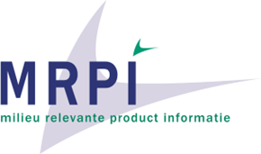
MRPI® - EPD certificates – All fees excluding VAT

New certificate
1st | € 1.650,-
2nd | € 1.100,-
3rd | € 825,-
4 > | € 550,-
All of the above amounts include one rounds of corrections [1]
Number of certificates per year (from January 1st till December 31st)

Renew / update certificate [2] [3] [4]
1st | € 825,-
2nd | € 660,-
3 > | € 440,-
Use of logo MRPI® and ECO platform logo
- Registered MRPI®-certificate
- Publication on digital data node MRPI®
- Publication Eco Portal
- 1:1 admission to Nationale Milieudatabase possible

Fee ECO Platform (per year, total 5 years)
1 – 5 | € 110,-
5 – 10 | € 55,-
10 > | € 6,-

Fee Publication Nationale Milieudatabase*
1st | € 400,-
2> | € 200,-
*This is excluding the fees charged by NMD

[1] Please be advised that the listed price includes only ONE round of corrections. Any additional correction rounds beyond the first will incur extra charges, which will be billed accordingly.  [2] A renewed MRPI®-EPD certificate is the continuation of an existing certificate which is PAST the ‘Expiry date’.  [3] An updated MRPI®-EPD certificate is an update of an existing certificate BEFORE the ‘Expiry date’.  [4] For a renewed/updated MRPI®-EPD certificate the fee is half the fee of a new MRPI®-EPD certificate. | 