recognition scheme VERIFIERS MRPI®/EPD 2017
APPLICATION FORM RECOGNIZED VERIFIER
May 2017, V3.1 FINAL

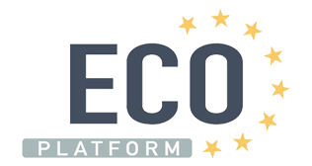

Stichting MRPI®
Kingsfordweg 151
1043 GR Amsterdam
The Netherlands
info@mrpi.nl

MRPI® VERIFIER APPLICATION FORM
Agency’s name

Address

Postcode and town

Telephone

Name contact

E-mail

Ch. Of Comm. Number

VAT number

Herein lawfully represented by:

Name

Position

Applies herein for recognition as an MRPI® VERIFIER. The applicant declares herein that it is aware of the content of the Recognition scheme verifiers MRPI® May 2017, v3.1 FINAL and declares herein that it will comply with it and agrees to pay the following costs arising from the Scheme:
- annual contribution by the MRPI® VERIFIER amounting to € 1500,-
Please find enclosed 3 LCA studies according to the “Bepalingsmethode, See Clause 1” which demonstrate the knowledge and experience of the applicant in carrying out LCAs. The LCA studies are at the maximum 3 years old.

Signature:

Date:
To be sent to:
Stichting MRPI®
info@mrpi.nl

